/ Subproject  IDA/EINRC framework 501998  Specific Agreement-7/EIONET | Authors  TietoEnator Corporation | Date issued / Version  15 November 2004/0.1 | Design Report
Client  European Commission  DG Environment / B 1 | Info  Detailed design and guidelines for usage and installation of Dynamical Online Help system and Help Admin Tool |  | Reference / Page  0000.doc  / 1 of 20

EUROPEAN COMMISSION

ENVIRONMENT DIRECTORATE-GENERAL

IDA-Programme -Framework Contract No 501 998 - 7th Specific Agreement

Einrc - Eionet

Detailed Design
Dynamical Online Help (DynOHelp) system
Help Admin Tool (HAT)


Modification history
Date | Version | Author | Reason for modification
15.11.2004 | 0.1 | J.Heinlaid | Creation of this document

APPROVAL PROCEDURE
Reviewer | Version | Start  Date | Finish  Date | Required modification/Approval/Comments
Framew.Mgr | 0.1 | 17.11.04
Proj. Leader | 0.1 | 17.11.04
CMT review
Commission/Project Officer's Approval

Table of Contents

1 Basic concept 5
2 Quicklinks to start using DynOHelp 6
3 Data model 6
3.1 The model’s description 6
3.2 How to create the model in the database 7
4 DynOHelp library 8
4.1 The API for target application 8
4.2 The API over XML-RPC 8
4.2.1 Methods 9
4.2.2 Authentication 11
4.3 Installation, configuration and how to start using 12
4.3.1 Installation 12
4.3.2 Configuration 12
4.3.3 How to start using 13
5 Help Admin Tool (HAT) 14
5.1 Installation 14
5.1.1 Setting up the run-time environment 14
5.1.2 Setting up the HAT web application 14
5.2 Configuration 18
5.3 Running and using HAT 18

F o r e w o r d

This document describes the detailed design of the Dynamical Online Help system (DynOHelp) and the Help Admin Tool (HAT) which is presented here as one of possible clients of the XML-RPC services that the DynOHelp provides. DynOHelp is a library enabling to dynamically manage the online help texts of Reportnet applications by using the XML-RPC protocol.
Purpose of this document is two-fold: it is for developers responsible for maintenance and further development of the software. But it is also written to be the guidelines for developers of Reportnet applications that are seen as potential target applications for the DynOHelp system.
The DynOHelp system is a simple Java library (a JAR file) containing built code for managing and retrieving online help texts of an application that uses this library. The management functions can be published over XML-RPC and the HAT is a web application with a web interface enabling to use these functions.

Basic concept
While developing the Data Dictionary (DD) for Reportnet, it was soon discovered that it would be- first- very useful to have some online help in the system’s web interface and- second- it would be even more useful if that help could be dynamically administered (i.e. the help texts would not be statically hard-coded but instead they would be stored in a database and editable via web interface). The third requirement was that help texts are interpreted as HTML code (i.e. users would be editing certain parts of the UI pages). And finally, the fourth requirement was to have all this functionality implemented as a Java library re-usable in many projects. The library became called Dynamical Online Help (DynOHelp) and the web client for editing help texts became called Help Admin Tool (HAT).
Figure 1 illustrates how an application could use the DynOHelp system (such an application in DynOHelp’s terms would be called a target application) and how the help content can be edited from HAT. As you can see, DynOHelp can re-used in many applications while a single HAT is capable of communicating to many applications as long as configured so. It is expected that users of HAT log onto applications using the latter’s user authentication API. Applications check if the authenticated user coming from HAT has permissions to edit the application’s Online Help texts. HAT communicates with applications over DynOHelp API and XML-RPC protocol.

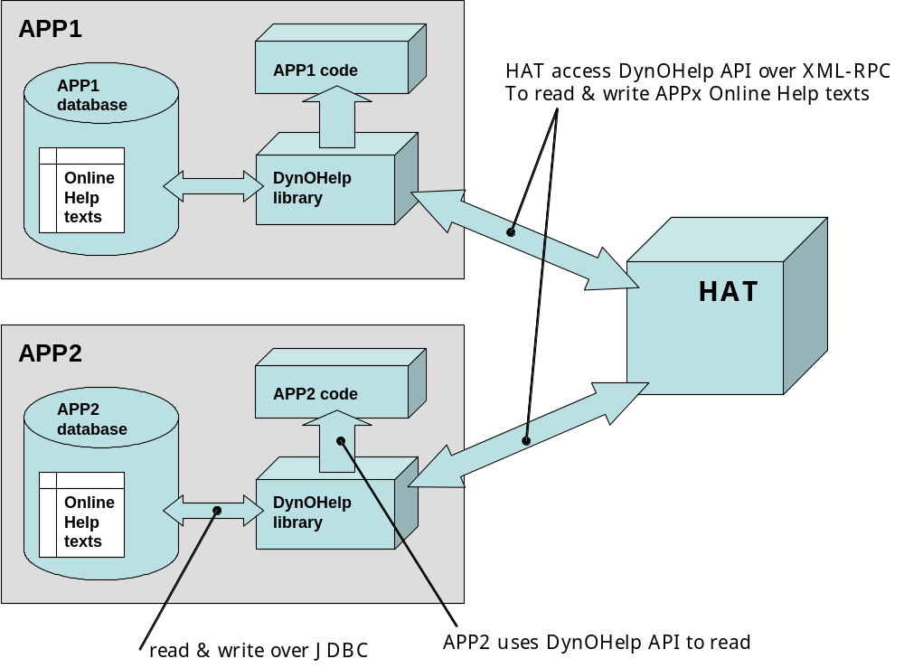
Figure 1. Basic concept of DynOHelp

Quicklinks to start using DynOHelp
- Instructions on installing and configuring a target application to start using DynOHelp are in chapter 3.
- Instructions for configuring the central help admin tool HAT to recognise the new target application are in Chapter 4.1.
- DynOHelp requires the presence of Access Control Lists (ACL) in the target application‘s database. Instructions on how to configure the ACL in target application to recognise the new DynOHelp component are in chapter 4 of the ACL document at
http://nmc.eionet.eu.int:8980/Members/irc/eionet-nmc/einrc/library?l=/einrc_sa6_2003/ait/ait-acl-_ddv11doc/_EN_1.1_&a=d
- Finally, through the ACL Admin Tool the EIONET helpdesk will give certain user accounts access permissions to the target application’s DynOHelp functions. These are the accounts to use when logging into HAT.

Data model

The model’s description
As you saw from above, an application’s dynamical online help data is kept in the application’s database. More precisely- it is kept in two tables, described in figure 2 below.
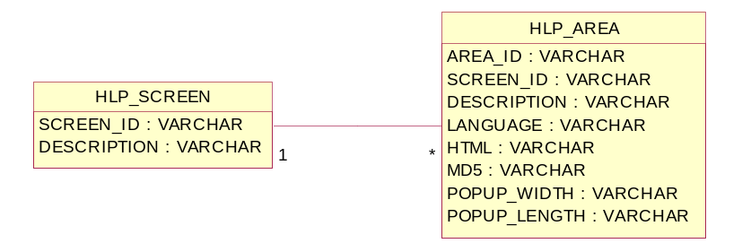
Figure 2. The data model of dynamical online help

From the above model’s point of view an application’s web interface is divided into screens (every user page or view is seen as a screen) and every screen is divided into areas (sections of user pages and views). The idea of Dynamical Online Help is that an area’s HTML code is editable. So in principal, users will not be editing simply some texts, but the HTML contents of the application’s UI that happen to be the online help displayed.
So in the above model the HLP_SCREEN table is where screens are managed and HLP_AREA is the table where the areas of screens are managed.
A screen is uniquely identified by the HLP_SCREEN.SCREEN_ID field in HLP_SCREEN table which is a simple free text, with white space allowed. A screen is described (so that users know which concrete screen of the UI are we talking about) by the HLP_SCREEN.DESCRIPTION field.
An area in a screen is uniquely identified by the HLP_AREA.AREA_ID and HLP_AREA.SCREEN_ID fields where the latter is a foreign key to HLP_SCREEN.SCREEN_ID. AREA_ID is a free text, with white space allowed. An area is described (so that users know which concrete part of the UI screen are we talking about) by the HLP_AREA.DESCRIPTION field.
HTML contents of an area are kept in HLP_AREA.HTML field.
The HLP_AREA.LANGUAGE field is not used, but is meant for future developments when the online help data might become multi-lingual.
The HLP_AREA.MD5 field is also not used, but is meant to be the MD5 hash of AREA_ID + SCREEN_ID.
If an area’s HTML contents are to be displayed as a body of a popup screen then the width and height of that popup screen are kept in HLP_AREA.POPUP_WIDTH and HLP_AREA.POPUP_LENGTH fields respectively.

How to create the model in the database
If an application wants to use the DynOHelp mechanism, the first thing it’s got to have are the above-described two tables in its database. It can be done by executing the following SQL script, tested and used with MySQL database engine:

CREATE TABLE HLP_SCREEN (
SCREEN_ID varchar(100) NOT NULL default '',
DESCRIPTION text NOT NULL default '',
PRIMARY KEY (SCREEN_ID)
);

CREATE TABLE HLP_AREA (
AREA_ID varchar(100) NOT NULL default '',
SCREEN_ID varchar(100) NOT NULL default '',
DESCRIPTION text NOT NULL default '',
LANGUAGE varchar(100) NOT NULL default '',
HTML text NOT NULL default '',
MD5 varchar(32) NOT NULL default '',
POPUP_WIDTH varchar(10) NOT NULL default '400',
POPUP_LENGTH varchar(10) NOT NULL default '400',
PRIMARY KEY (AREA_ID, SCREEN_ID, LANGUAGE)
);

DynOHelp library
Once an application has the Dynamical Online Help data model in its database, the next thing it’s got to have is the DynOHelp Java library which the developers should receive as a uit-help.jar file. The latter has an API both for the target application (the application that uses the help system) and the HAT which is used to edit the content of the help. For HAT the API is published over XML-RPC.

The API for target application
For the target application the API is provided by com.tee.uit.help.Helps class and only 3 static methods should be of interest::
- public static String get(String, String)
This one returns the HTML content of the given area. The first input string must contain the ID of the screen, the second one must contain the ID of the area. This method does not throw exceptions, nor does it ever return a NULL. If it doesn’t find the required area content, it returns a zero-length string.
- public static String getPopupWidth(String, String)
If an area’s HTML contents are to be displayed as a body of a popup screen then the width of that popup screen is returned by this method. The first input string must contain the ID of the screen, the second one must contain the ID of the area. The returned string contains the number (no unit given) that the popup width is. If no given area is found, the method returns a zero-length string. No exceptions ever thrown.
- public static String getPopupLength(String, String)
If an area’s HTML contents are to be displayed as a body of a popup screen then the height of that popup screen is returned by this method. The first input string must contain the ID of the screen, the second one must contain the ID of the area. The returned string contains the number (no unit given) that the popup height is. If no given area is found, the method returns a zero-length string. No exceptions ever thrown.

So if a target application’s developer wants to use the above API, it must import the com.tee.uit.help.Helps class and call the above methods. But he/she must of course know the IDs of the screens and areas. That’s one thing that the help’s creators and DynOHelp users must agree.

The API over XML-RPC
In order to use the DynOHelp API over XML-RPC, one must first know the URL of the target application’s RPC router and then the name of the DynOHelp’s XML-RPC service. The URL must be told by the target application’s developer. The name of the DynOHelp’s XML-RPC service is “HelpService” (quotes not included). This the name to use when connecting to DynOHelp XML-RPC service (see code snappet below).

Methods
The API over XML-RPC is provided by com.tee.uit.help.RemoteService class and consists of the following methods. All the methods require that the XML-RPC client has first authenticated itself against the target application’s user authentication and has the permission to edit the application’s help data. See the next chapter for more.
- ARRAY getScreens()
Returns all found screens as an ARRAY of STRUCTs where every STRUCT corresponds to single screen. Every STRUCT has 2 keys:
id - screen ID
descr – screen description
If no screens are found, the method returns an empty ARRAY.

- ARRAY getAreas(STRING)
Returns all areas found for the given screen. The input STRING must contain the screen ID. The output is an ARRAY or STRUCTs where each STRUCT represents a single area. Every STRUCT has the following keys:
id – area ID
screen_id – screen ID
descr – area description
popup-width – the width of the popup corresponding to the area
popup-length – the height of the popup corresponding to the area
md5 – MD5 hash of screen ID + area ID
If no areas are found, the method returns an empty ARRAY.

- STRUCT getHtmls(STRING, STRING)
Returns a STRUCT containing the HTML content for the given area. The first input STRING must contain the screen ID, the second one must contain the ID of the area in that screen. The returned STRUCT consists of key-value pairs where every key represents a language and the corresponding value contains the HTML content for that language. For example the STRUCT could look like this:
{
“en” : “this is HTML content in English”,
“et” : “this is HTML content in Estonian”
“” : “this is HTML content in default language”
}
Notice that the default language is identified by an empty string. It is always so!
If mo HTML contents are found for the given area, the method returns an empty STRUCT.

- STRING createScreen(STRING, STRING)
The method creates a new screen where the screen ID is given by the first input STRING and the screen description is given by the second input STRING.
Since XML-RPC does not support a void data type, the method always returns an empty STRING.

- STRING createArea(STRING, STRING, STRING)
The method creates a new area in the given screen. The first input STRING must contain the screen ID, the second input STRING must contain the area ID and the third one must contain the area’s description.
Since XML-RPC does not support a void data type, the method always returns an empty STRING.

- STRING removeScreens(ARRAY)
The method deletes existence of the screens given with the input ARRAY. The latter is an ARRAY of STRINGs where every STRING contains the id of a screen to delete.
Since XML-RPC does not support a void data type, the method always returns an empty STRING.

- STRING removeAreas(STRING, ARRAY)
The method deletes existence of the areas given with the input STRING and ARRAY. The STRING must contain the id of the screen from which to delete the areas. The ARRAY consists of STRINGs where every STRING identifies an areas to delete.
Since XML-RPC does not support a void data type, the method always returns an empty STRING.

- STRING editHtml(STRING, STRING, STRING)
The method changes the HTML content of the default language of the given area. The first INPUT string must contain the screen ID, the second one must contain the area ID and the third one must contain the new HTML content in default language.
Since XML-RPC does not support a void data type, the method always returns an empty STRING.

- STRING editArea(STRING, STRING, STRING, STRING, STRING)
The method changes the HTML content of the default language, the popup width and the popup length of the given area. The first INPUT string must contain the screen ID, the second one must contain the area ID, the third one must contain the new HTML content of the default language and the fourth and fifth input STRING must contain the area’s popup width and height respectively. Since XML-RPC does not support a void data type, the method always returns an empty STRING.
- STRING reset()
DynOHelp loads the help data from database into memory to better serve its XML-RPC clients. This method forces DynOHelp to reload all help data from the database. The idea of this method is to call it after createScreen(), createArea(), removeScreens(), removeAreas(), editHtml() or editArea() has been called, so to make it sure that DynOHelp has the latest stuff in its memory.
Since XML-RPC does not support a void data type, the method always returns an empty STRING.

Authentication
As it was said above, all the DynOHelp XML-RPC methods require that the XML-RPC client has first authenticated itself against the target application’s user authentication and has the permission to edit the application’s help data.
Authentication must happen on the basis of basic HTTP authentication. How to do it, depends on the way you’re implementing your XML-RPC client. For example Apache’s implementation of XML-RPC for Java has the following method for submitting the user name and password from client side:
org.apache.xmlrpc.XmlRpcClient.setBasicAuthentication(String,String)
The first input string in the above method must contain the username, the second one must be the user password. DynOHelp passes these credentials to its target application which authenticates the user and checks if the user has permissions to edit the application’s help data. If the user is not authenticated or the user does not have the required permission, DynOHelp throws an exception that lets you know.

If you are using the XML-RPC framework developed for Reportnet integration (and called the Application Integration Tool (AIT)), then in that framework the authentication can be done by calling
com.tee.uit.client.ServiceClientIF.setCredentials(String, String)
Again, the first input string contains the username, the second one is the password.

Installation, configuration and how to start using

Installation
For making an application work with Dynamical Online Help mechanism, the following steps have to be taken:
- Create the dynamical online help tables in the application’s database. See the data model chapter above.
- Copy uit-help.jar into the application’s Java classpath. Also, make sure the classpath has the following libraries too:
activation.jar
castor.jar
eionet-dir.jar
tomcat-util.jar
uit-client.jar
uit-definition.jar
uit-help.jar
uit-security.jar
uit-server.jar
xerces.jar
xmlrpc.jar
- Configure (see the next chapter)
- Start using (see the chapter after next chapter)

Configuration
- Make sure you have the following servlet declared and url-mapped in your application’s web.xml:
<servlet>
<servlet-name>rpcrouter</servlet-name>
<servlet-class>com.tee.uit.servlets.XmlRpcRouter</servlet-class>
</servlet>
<servlet-mapping>
<servlet-name>rpcrouter</servlet-name>
<url-pattern>/rpcrouter</url-pattern>
</servlet-mapping>

- Make sure you’re application has a directory with ACL files (it coule be something like app_home/acl) and the ACL-related tables created in the database (see the documentation of ACL mechanism at
http://nmc.eionet.eu.int:8980/Members/irc/eionet-nmc/einrc/library?l=/einrc_sa6_2003/ait/ait-acl-_ddv11doc/_EN_1.1_&a=d
- Make sure your application has the WEB-INF/classes/uit.properties file and it contains the following lines:
# file for acl permissions
application.acl.folder=app_home/acl
# file for groups and users
application.localgroups.file= app_home/acl/dd.group
# file for permissions + descriptions
application.permissions.file= app_home/acl/dd.prms
acl.owner.permission=c
acl.admin=true
# component services
componentservices=HelpService
componentservices.HelpService.provider=com.tee.uit.help.RemoteService

How to start using
In the target application import the com.tee.uit.help.Helps class and use its 3 methods described in the chapter about DynOHelp API above.
In the XML-RPC client, if you are using the Reportnet integration framework (aka AIT) then this is a sample code of how to create a DynOHelp client, authenticate it and call its methods:
// import the client part of Reportnet integration framework
import com.tee.uit.client.*;
import java.util.Vector;

public class Sample {
public void sample() throws Exception{

// create the client
ServiceClientIF client = ServiceClients.getServiceClient(
"HelpService", "http://target_application/rpcrouter");

// authenticate the client
client.setCredentials("username", "password");

// get the list of areas in the "homepage" screens
Vector params = new Vector();
params.add("homepage");
Vector areas = client.getValue("getAreas", params);
System.out.println(areas);
}
}

Help Admin Tool (HAT)
HAT is a ready-made XML-RPC client for managing the online help content of applications that support the DynOHelp mechanism. HAT as a web-based user interface and can be configured to run against any DynOHelp-supporting application. HAT has no database of its own, it receives its operational data from the DynOHelp library of a target application (see the chapter about basic concept for illustration). It is a simple web-application and its installation, configuration and usage guidelines are presented in the following chapters.

Installation

Setting up the run-time environment
HAT runs in Apache’s Tomcat servlet engine environment which, in turn, runs on top of Apache’s Web Server. Guidelines on how to download the two, how to install them and set them up to run with each other, are available in the Data Dictionary (DD) installation manual, because it’s exactly the same story. The DD installation manual can be extracted from the DD software package which can be downloaded from http://www.eionet.eu.int/software/datadict. In the manual, follow these chapters:
- setting up the Java Runtime Environment
- setting up Apache Web Server
- setting up the Tomcat Servlet Engine
- connecting Apache Web Server and Tomcat Servlet Engine
The rest of the chapters are irrelevant.

Setting up the HAT web application
Once you’ve set up the HAT runtime environment and tested that it works, you can install and set up the HAT web application.

The HAT package
You might receive HAT as a ZIP or TGZ package, or you might receive it by downloading the already unpacked software from an EIONET CVS server. In the first case you simply need to unpack the package, with folder names included! In the second case, if you want to turn the unpacked software into a TGZ package, follow the next command:
shell> shell> tar cfz hat.tar.gz HAT_HOME
where the hat.tar.gz is the package you want to create and DD_HOME is the home directory of HAT application. The HAT directory structure looks like this:
/helpadmin
/public
JSP files, CSS files, JavaScript files
/images
image files used in HAT web pages
/WEB-INF
/classes
directory where the Java classes should be compiled to, home directory for HAT properties files
/lib
used external JAR libraries
/src
Java source and descriptor for build

In the following chapters the HAT’s root directory (/helpadmin) will be referred to as HAT home directory (HAT_HOME).

Building the HAT’s Java source
HAT’s Java source files are located in HAT_HOME/src. Since no built class files are offered with HAT package, you must build that source. It is recommended that for building you use an Apache’s tool called Ant. Apache Ant is a Java-based build tool with XML-formatted configuration. In theory, it is kind of like Make, but without Make's wrinkles. You can find out more at Ant’s homepage http://ant.apache.org/. The download is available at http://ant.apache.org/bindownload.cgi.
Please follow the guideliens at http://ant.apache.org/manual/index.html for installation.
Using Ant is fairly straight forward. You just have to prepare an XML-formatted build file and execute the following command:
shell> ant_home/bin/ant build.xml
In the above command line ant_home is the directory where Ant’s directories and files have been installed to and build.xml is the build file. A sample build file could look like this:

<project name="HAT" default="compile" basedir=".">

<!-- set global properties for this build -->
<property name="src" value="."/>
<property name="classes" value="../public/WEB-INF/classes"/>

<target name="compile">
<!-- Compile the java code from ${src} into ${build} -->
<javac srcdir="${src}" destdir="${classes}"
classpath="../public/WEB-INF/lib/castor.jar;
../public/WEB-INF/lib/eionet-dir.jar;
../public/WEB-INF/lib/jndi.jar;
../public/WEB-INF/lib/ldap.jar;
../public/WEB-INF/lib/providerutil.jar;
../public/WEB-INF/lib/uit-security.jar;
../public/WEB-INF/lib/uit-client.jar;
../public/WEB-INF/lib/uit-help.jar;
../public/WEB-INF/lib/uit-definition.jar;
../public/WEB-INF/lib/uit-server.jar;
../public/WEB-INF/lib/xmlrpc.jar;
../public/WEB-INF/lib/xmlserver.jar;
/var/lib/tomcat4/common/lib/[servletapi4].jar"/>
</target>
</project>

It is simplest to put Ant’s executable into your running environment’s PATH so that you can go to ANT_HOME/src and execute Ant from there, with exactly the above shown command. In that case you don’t actually need to change anything in the above build file! But if you don’t run Ant from ANT_HOME/src then you need to make sure that the paths in the build file are correct. The file speaks very much for itself, but you can find out more about its formatting from the Ant’s manual.

Setting up the HAT web
The HAT’s web setup is to be written into 2 files:
- server.xml file in TOMCAT_HOME/conf directory
- web.xml file in ANT_HOME/public/WEB-INF directory
NB! Before reading the following guidelines on concrete setup needs for HAT, please read first the Tomcat manuals on how to configure those files in general.

server.xml comes with Tomcat and that’s where you basically declare the existence of HAT application. In Tomcat’s terms a web application is a context. Here’s how to set up HAT’s context:
- in <Host name="localhost" debug="0" appBase="..." ...> declaration set the appBase to the full physical path of your web applications directory (the directory where ANT_HOME is residing!).
- between the <Host></Host> tags add the HAT's context as follows:
<!-- start of HAT context -->
<Host name="helpadmin.eionet.eu.int" debug="0" appBase="WEBS_HOME" unpackWARs="true">
<Context path='' docBase='HAT_HOME' debug='0' reloadable='true' crossContext='true'>
<Logger className="org.apache.catalina.logger.FileLogger" prefix="hat." suffix=".log" timestamp="true"/>
</Context>
</Host>
<!-- end of HAT context -->
web.xml is a file specific to your HAT application and it has to be in the HAT_HOME/public/WEB-INF directory. The file should look exactly like this:

<?xml version="1.0" encoding="ISO-8859-1"?>
<!DOCTYPE web-app PUBLIC "-//Sun Microsystems, Inc.//DTD Web Application 2.3//EN"
"http://java.sun.com/dtd/web-app_2_3.dtd">

<web-app>

<display-name>Help Administrator</display-name>
<description>Reportnet Help Administrator</description>

<!-- servlet declarations -->

<servlet>
<servlet-name>main</servlet-name>
<servlet-class>eionet.helpadm.servlets.Main</servlet-class>
</servlet>
<servlet>
<servlet-name>xmlrpcrouter</servlet-name>
<servlet-class>com.tee.uit.servlets.XmlRpcRouter</servlet-class>
</servlet>

<!-- servlet mappings -->

<servlet-mapping>
<servlet-name>main</servlet-name>
<url-pattern>/main</url-pattern>
</servlet-mapping>
<servlet-mapping>
<servlet-name>xmlrpcrouter</servlet-name>
<url-pattern>/rpcrouter/*</url-pattern>
</servlet-mapping>

<!-- the welcome file -->

<welcome-file-list>
<welcome-file>main</welcome-file>
</welcome-file-list>

</web-app>

Configuration
The Help Admin Tool is easy to configure, because it does not expect any context parameters from web.xml and it has only one configuration file:
HAT_HOME/publiC/WEB-INF/classes/helpadmin.properties
The file contains the declarations of target applications that HAT should communicate with. Declaration of a target application consists of two lines, for example:
applications=DataDict
DataDict.router.url=http://dd.eionet.eu.int/rpcrouter
The first line declares that there is an application that should be called DataDict in HAT’s UI pages. The second lines declares the full URL of the application’s XML-RPC router.
So if you want to make HAT work with a new target application, just give it a name and declare the application’s XML-RPC router URL with name.router.url property. Declaration of a new application requires the web server and Tomcat to be restarted! See the next chapter about running the web.

Running and using HAT
By now you should finally be ready to run the HAT web. Since it requires both Apache and Tomcat, you need to start both of them. It is always suggested to start and restart Tomcat first and Apache second. Because if you make any changes to DD web configuration in Tomcat, Apache will not become aware of them unless Tomcat has been started in the first place.
If Tomcat and Apache did not produce any fatal error messages, you should be able to check if the HAT web is running OK. Assuming that in server.xml you have declared the web path of HAT’s to be http://hat.mydomain.int, you should go to that URL and see if the home page opens without problems. If it opens nicely then HAT should display the list of declared target applications and you can start working with an application by clicking its name. The click opens a window where you can log into the application. If the login goes OK, you will be provided with a list of all help screens found in this application. If the login does not go OK, you get an exception.
For further guidelines on how to use Help Admin Tool’s web interface, see the HAT User Guide at
http://nmc.eionet.eu.int:8980/Members/irc/eionet-nmc/einrc/library?l=/einrc_sa7_2004/dd/hat_user_guidedoc/_EN_1.0_&a=d

